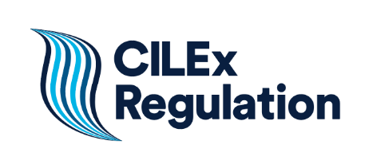
Risk Management: useful links

The following is a list of useful organisations and websites that may assist you in managing risk. Many will help you stay up to date by providing regular information and updates through email or blog alerts.
Companies House
Companies House will register the information companies are legally required to supply and make that information available to the public.
Cyber Essentials
Cyber Essentials is a government-backed, industry-supported scheme to help organisations protect themselves against common cyberattacks.
Cyber Incident Response (CIR) service
The CIR is a small government-run scheme certified by the CESG (originally known as the Communications-Electronics Security Group) and the Centre for the Protection of National Infrastructure (CPNI) for firms that have been attacked.
Data Protection - ICO
The Information Commisioner’s Office (ICO) is responsible for the enforcement of the Data Protection Act 2018 and the General Data Protection Regulation and is also responsible for Freedom of Information. It offers guidance on principles of data protection.
Department for Business Energy & Industrial Strategy - DBEIS
This department provides advice to businesses.
Financial Fraud Action UK
This is a website set up by the UK payments industry. Advice to business owners and consumers.
Cont…/
Financial Ombudsman
The Financial Ombudsman Service was set up by law as an independent public body. Its job is to resolve individual disputes between consumers and businesses about financial problems.
Fraud Advisory Panel
The Fraud Advisory Panel is a charitable company set up to provide knowledge, skills and resources to protect against fraud.
Guidance section of the website
Guidance on Anti-money Laundering
Get Safe Online
Get Safe Online is a public/private sector partnership supported by HM Government and organisations in banking, retail, Internet security and other sectors. It is a website designed to give practical advice to protect you, your computers, mobile devices and your business from fraud, identity theft, viruses and other problems encountered online. It is a Cyber Essentials and IASME certified organisation. Additional guidance for business.
IASME
The IASME standard is an achievable cyber security standard for small companies.
Land Registry
The Land Registry registers the ownership of land and property in England and Wales. It offers a free Property Alert service to help prevent property fraud.
Property Alert
Protect Property from Fraud
Legal Ombudsman (LeO)
It uses the benefit of its experience to help a broad range of professions to improve complaint handling processes and to avoid complaints arising in the first place.
Money Laundering Regulations 2017/Proceeds of Crime Act 2002
The requirements of the UK anti-money laundering regime are set out in these two Acts.
Money Laundering Regulations 2017
Proceeds of Crime Act 2002
National Crime Agency
The National Crime Agency is a national law enforcement agency in the UK.
NCA Cyber Crime
NCA Suspicious Activity Reports

National Fraud and Cyber Crime Reporting Unit (Action Fraud)
Action Fraud is the UK's national fraud and Internet crime reporting centre.
National Fraud Database
The National Fraud Database contains data on hundreds of thousands of confirmed cases of fraud.
SARs online
Cont…/
National Crime Agency (NCA) system for making Suspicious Activity Reports (SARs).
UK Finance
This is the trade association for mortgage lenders in the UK.

Health and Safety
The Health and Safety Executive’s website:
Advice on how to manage Health and Safety
Health and Safety advice specific to the office environment

